Cumulative Grade Point Average Calculator
Name of Student- Viya Harpalani
Registration Number-25BHI10089
Collage-VIT Bhopal
Topic-CGPA calculator

- Introduction
The purpose of this project is to provide an automated system to calculate Grade Point Averages (GPA) and Cumulative Grade Point Averages (CGPA) based on course credits and marks received which will allow students to compute academic results in an easier, safer, and quicker way with no errors.
_________________________________________
- Problem Statement
Computation of grades is cumbersome, error-prone and, as the academic programs grow, it is not scalable. Students and educational institutions require a tool that is accurate, immediate and dependable to track and analyze student academic performance.
________________________________________
- Functional Requirements
- Computi grade points based on marks that the user will enter.
- Accept credits to subjects at subject level to be used on weighted average CGPA calculations.
Marks input values must be in the range of 0 to 100, and the credits must be greater than 0.
- Output the CGPA computed to two decimal places.
- Display messages to errors, failure and invalid input.
- Accept multiple subjects entered.
_________________________________________
5. Non-functional Requirements
- The application must be user-friendly. (easy to use).
- Minimalll time for computation to be completed. (results in real-time)
- Data entered by the user must be validated and secured while processing.
- The system must be resilient with invalid input and handle exceptions with failure gracefully.
- The codebese must be maintainable and extensible.

- Structure of the System
The structure is modular and consists of an input module, validation logic, computation module, and output/display logic. Future extensibility points may include connecting to a student database or possibly providing a web interfonce.
________________________________________
- Design Diagrams Use Case Diagram:
Actors: Student/User
- Use Cases: Enter Marks/ Credits, Calculate Grade Point, Display CGPA, Generate Errors Workflow Diagram:
- Begin→ Input Subject Information → Validate or Not → Calculate Grade Point → Save Totals → Loop or End → Calculate CGPA → Display Results
Sequence Diagram:
- User → System: provides marks/credits.
- System: valid input
- System: calculates grade point
- System: saves accumulators
- User → System: generates calculation.
- System: calculates and display CGPA
Class/Component Diagram:
- res.py: This is the main module that mediates user input, computation, and output.
- GradeCalculator: calculates grade point from marks
- InputValidator: checks marks and grades
- CGPAEngine: calculates overall CGPA
ER Diagram: (If storage was used; as there is none for calc. this is omitable.)
- Entities: Student, Subject, GradePoints, Credit
________________________________________
8. Design Decisions & Rationale
- Threshold-based grading: simplicity with if-else logic is easier to read and maintain.
- Input Validation: Validate immediately rather than having multiple inputs led to more erroneous input.
- Weighted CGPA formula: fair and accurate for subjects with different credit values
- CLI Implementation: Focused on minimal requirements and general-purpose specification, with simple extension to web or GUI.
________________________________________
9. Implementation Details
Implemented in Python, using simple I/O.
- Involves robust exception handling and input validation.
- Results are displayed to two decimal places.
- Modularized functions for grade average percentage calculator
- Screenshots / Results

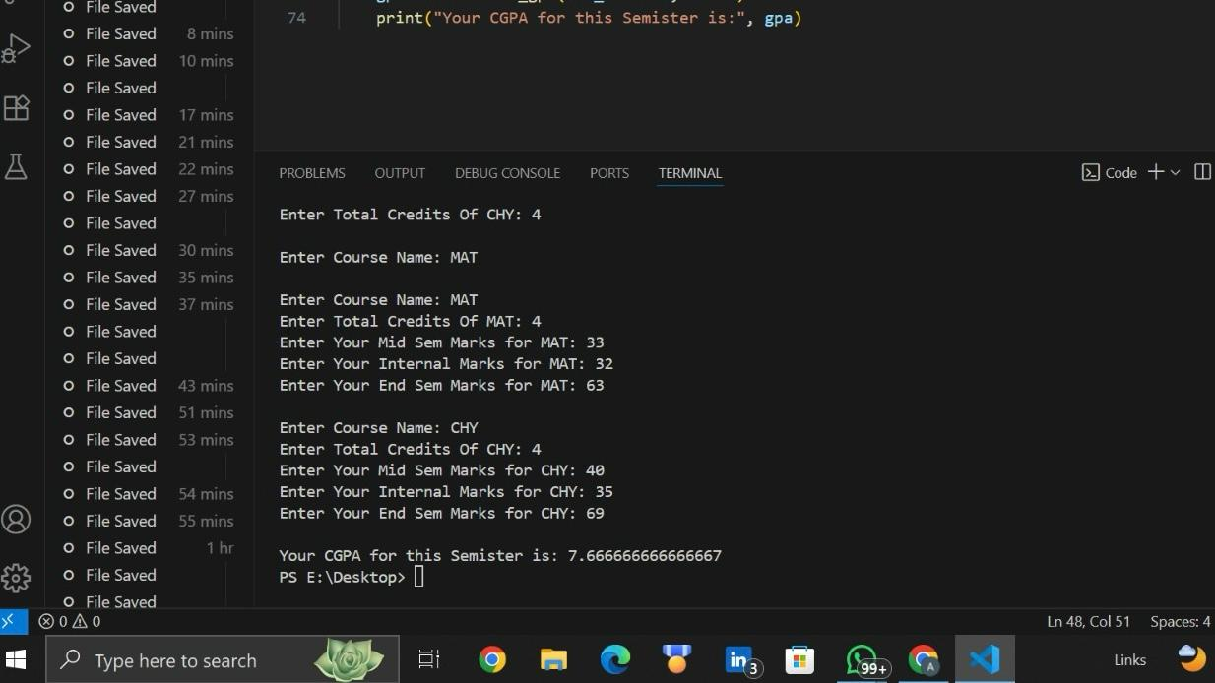
________________________________________
- Testing Strategy
Unit Testing: Functions for grade point calculation and CGPA were tested with edge values (0/100, negative/over-bound values).
Input Validation Testing: Ensured invalid marks/credit data was rejected.
• Integration Testing: End-to-end testing to confirm proper aggregation and output in different input scenarios.
________________________________________
12. Challenges Faced
- Validation for different types of invalid input: negative, non-numeric, above 100 marks
- Ensuring correct floating-point division and rounding
- Keeping the system flexible for a potential extension to a persistent database
________________________________________
13. Learnings & Key Takeaways
- Importance of Input Validation in User-Facing Applications
- Need for modular code that allows easy maintenance and extensibility
- Value of direct feedback, clear error messages to guide users
_________________________________________
14. Future Enhancements
- Integration with a database or web interface for persistent storage and multi-user support
- Improvements to the user interface: GUI or web-based
- Implementation of additional grading schemes - letter grades, custom scales
- Export/Email calculation results
- Support for semester-wise or cumulative year CGPA computation
________________________________________
15. References
• “Design and Implementation of a Cumulative Grade Point Average Management System”

_________________________________________

